

**Aggie Snap Project**

Team 19

Saif Ali, Chris Folleras, Bryce Schumacher

November 30, 2014

**Introduction**

Our project assigned for our CS 121 class this year is the Aggie Snap Program. This project’s goal is for teams to create a simple functioning version of Facebook or Instagram’s photo sharing system which utilizes the ability to store pictures to a database, add tags, and search and browse through the picture database. For this project teams were assigned to groups of three in which the work load would be divided amongst the members. Our team members for this project are Saif Ali, Chris Folleras and, Bryce Schumacher. Upon meeting it was decided that each member would be responsible for two of the deliverables for the project as well as any extra credit that could be achieved in the time allotted for the project. The project deliverables are as follows.

1. *Get a picture from a filename. Allow the user to recover from entering an incorrect type of file, a file that can't be opened, etc.*
2. *Get a picture from a URL. Allow the user to recover from entering an incorrect file extension, a URL that can't be downloaded, etc.*
3. *Add up to 5 tags per picture (Family, Friends, Aggieland, Pets, Vacation, or any combination of these).*
4. *Save the picture to disk, and save information to a picture index file.*
5. *Browse all pictures. When a picture is displayed, so are its tags. Provide buttons to see the next or the previous picture.*
6. *Find pictures with any combination of tags. Provide buttons to see the next or the previous picture with those tags.*

It was decided after reading through these deliverables and assessing our team’s strengths andweaknesses that Chris would be responsible for items one and two, Bryce for items three and four, and Saif for items five and six. With our work break down complete planning and coding could begin.

**Problem Statement**

For this project, as it was previously stated, our job was to create a working photo sharing database that can be used to upload, tag, and browse pictures using C++ 11 and FTLK. By completing this project it is our teams hope that we have a greater understanding of not only C++, but also a grasp on the design process of real world software applications, the problem solving associated with these tasks as well as the unstated management duties that come with a project such as time management, team work, and work ethic. Though at some points some of these tasks seemed challenging, we fully believe that we have held ourselves to the standards we have initially set.

**Restrictions and Limitations**

With any commissioned project there of course must be restrictions and limitations. We viewed this project as a product we would be designing for a client, and naturally any client will have a set of deliverables as well as guidelines to shape the development of the project. For this project our team was required to use at least two C++ 11 features in our code, create at least two classes per person with separate header and implementation files, follow appropriate C++ style, and limit functions to no more than 24 lines of code. In addition each team member is required to have a rough idea of each other members code. With these guide lines in hand we set to work on our code.

**Implementation**

Our program begins with an upload window that displays an image input field as well as five photo tag fields. When the program first launches it waits for user input in the file field and the tag fields. When the upload button is pressed the program first tests to see if the file is a URL or if it is a local file. The program then executes our first extra credit task, completed by Saif, which reads the file extension backwards until it reaches a period. It then cross references a vector of accepted extensions. Up to one-thousand extensions can be accepted if they are added to the exts vector. If this search is successful the photo can then be uploaded. If the upload succeeds the photo is then moved into the picture folder and the photos information such as name and tags is then added to a database file. If the input succeeds the window then displays “Image upload successful” if not an error message is displayed and none of the information is written to the database. Next the program waits to see if the user wishes to input another file, move on to the browse window or quit the program.

If the browse button is pressed the browse window is called which contains a whole host of features. At the top of the window there is a field to search tags. If a tag has been associated with a picture the program iterates through the database file to find all photos associated with that tag. Then the next and previous buttons can be used to cycle through these pictures. Next to the search tags field is the upload button which, when pressed, redraws the upload window and loops back to the beginning of the program to allow more photos to be uploaded. The reset button located directly next to the upload button refreshes the current window if some sort of minor error occurs.

Moving on to the right hand side of the window there are the two previous and next buttons that cycle through each photo loaded in the database. If a tag has been searched these buttons only scroll through the photos containing that tag or tags. Below these buttons is our second extra credit, the modify tags option, executed by Bryce. The user at any point while browsing through can change the tags displayed in each of the current fields. This works by overwriting that section of the database file and replacing the old tags with the new modified ones. Once modified these new tags can be searched without a recompile of the program.

In the center of the browse window the current photo is displayed. If too large, the photo is masked by the program to allow it to fit within the preset window size. Underneath the photo the name of the file is displayed along with its file type. Below this is our final extra credit, the Exif data, completed by Chris. This uses a built in C++ function to get the date and time data either from the local file or the upload. This function is then run using the time.h header file. Next to the date and time data the counter displays the amount of images in the database, or the images contained in the current tag search. Finally a quit button is included to terminate the program when finished.

**Sample Run**

Program at launch

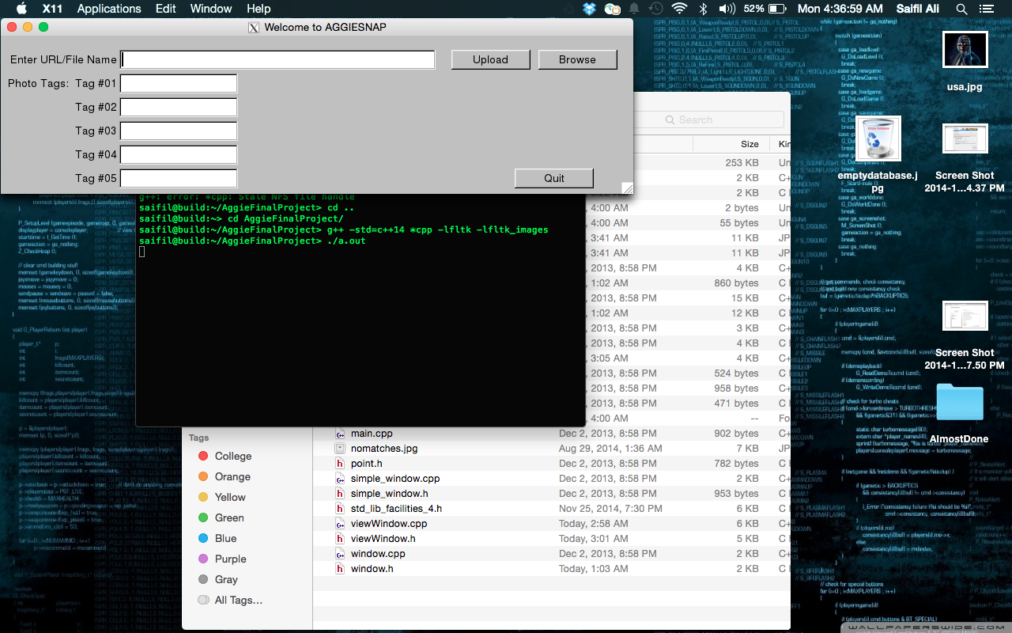

Standard .png upload with tags

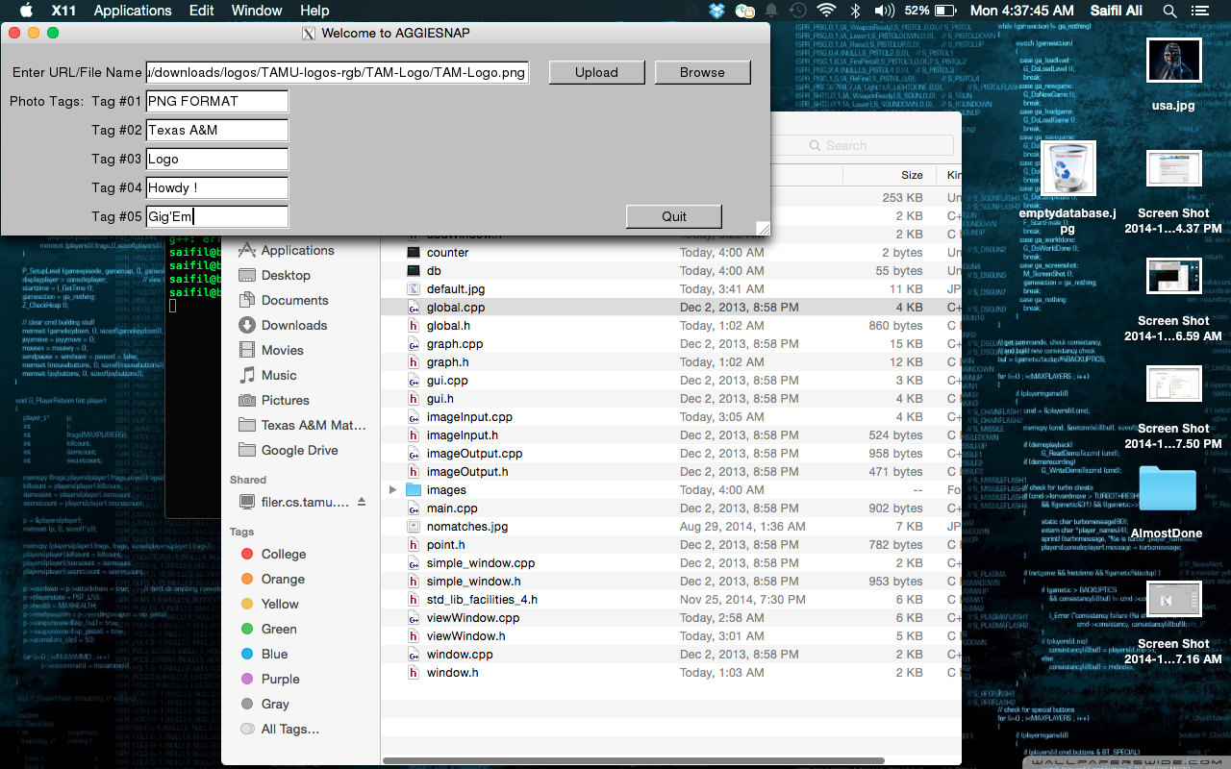

Upload successful .

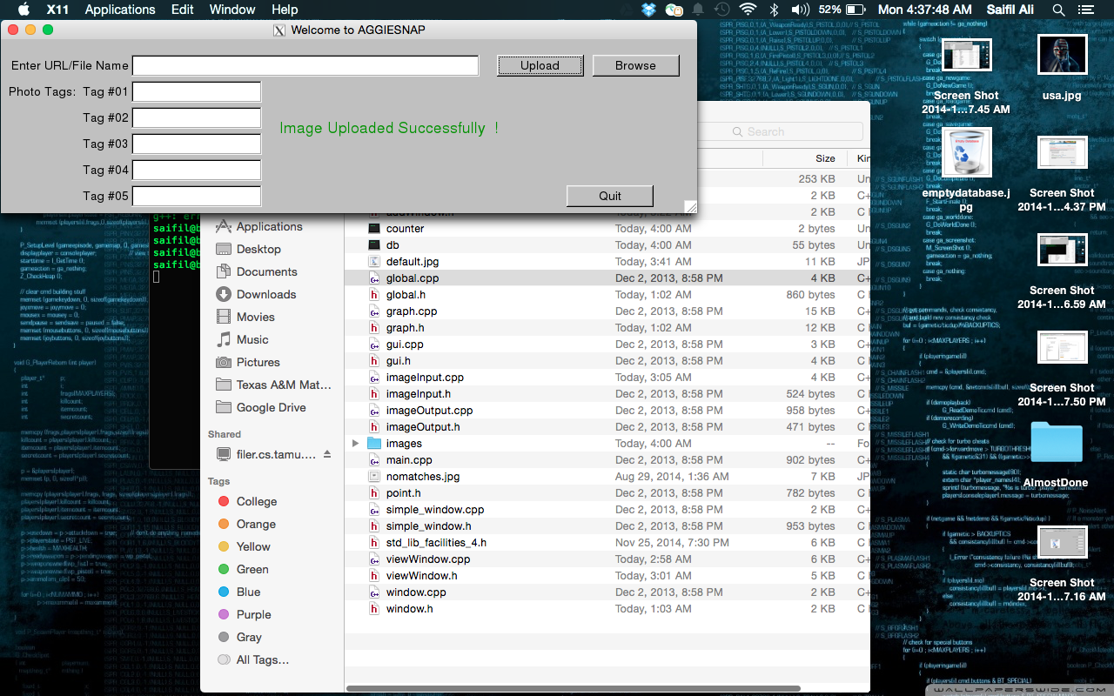

If image is invalid 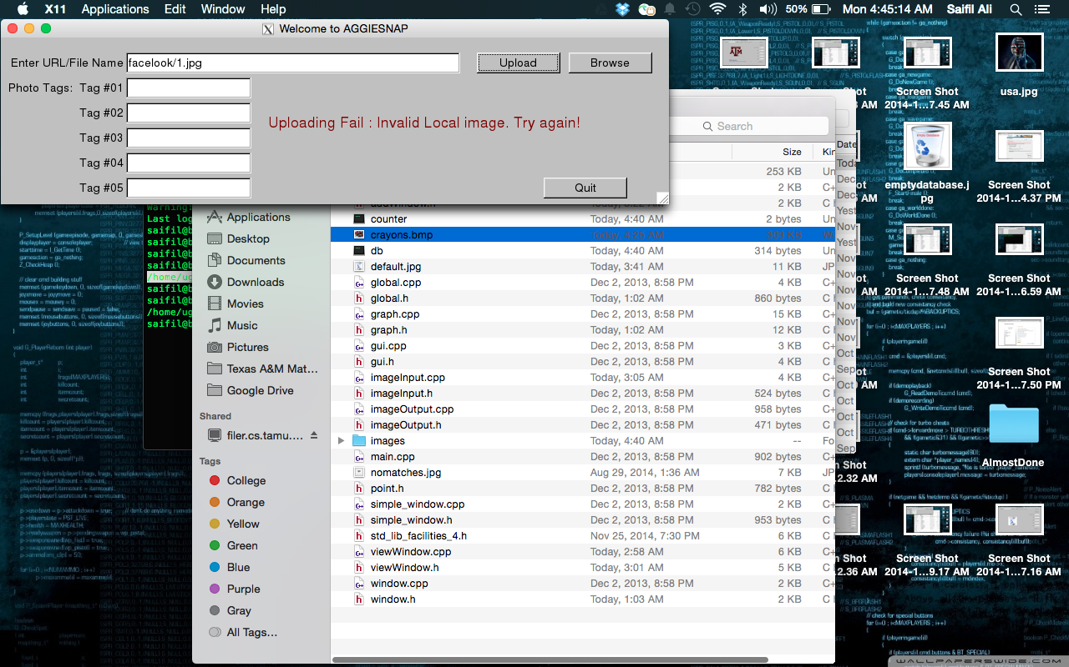

If file extension is invalid

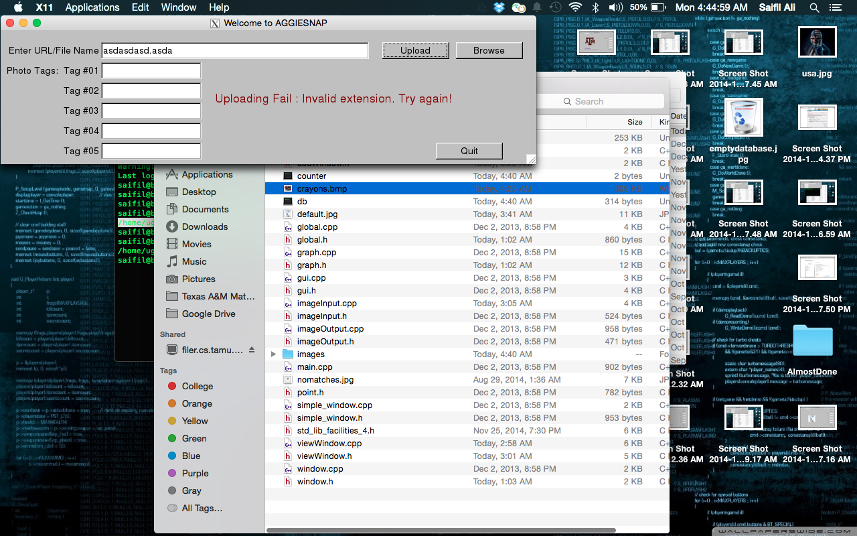

.jpg upload with tags

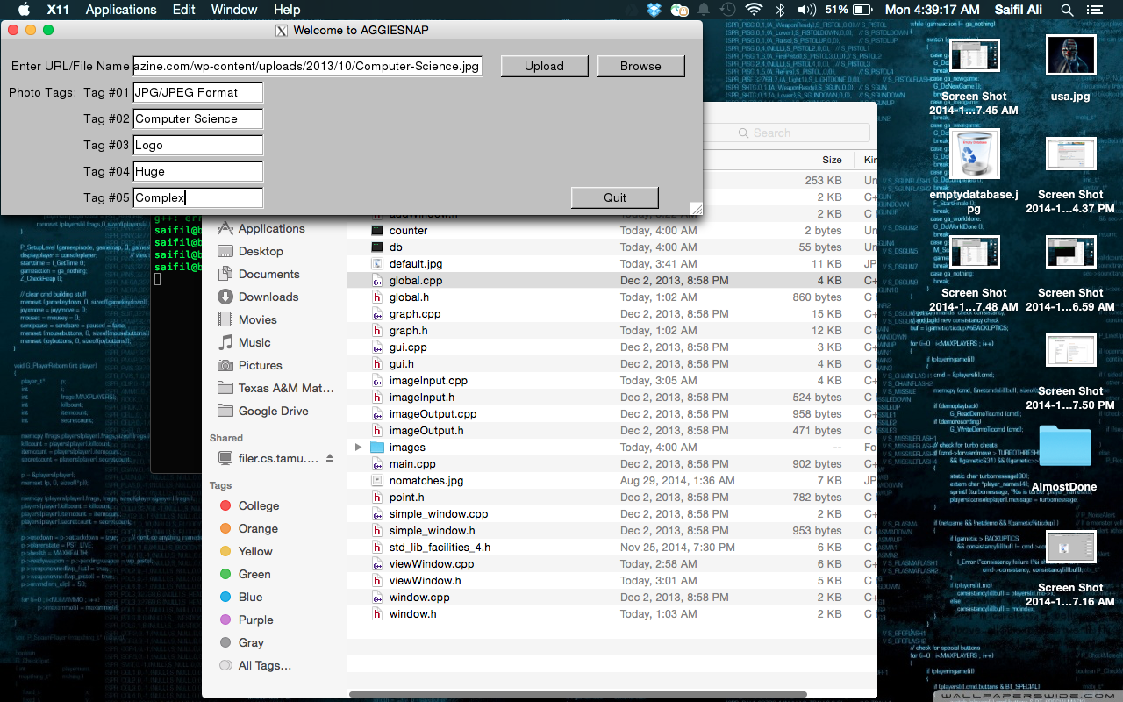

.bmp upload with tags

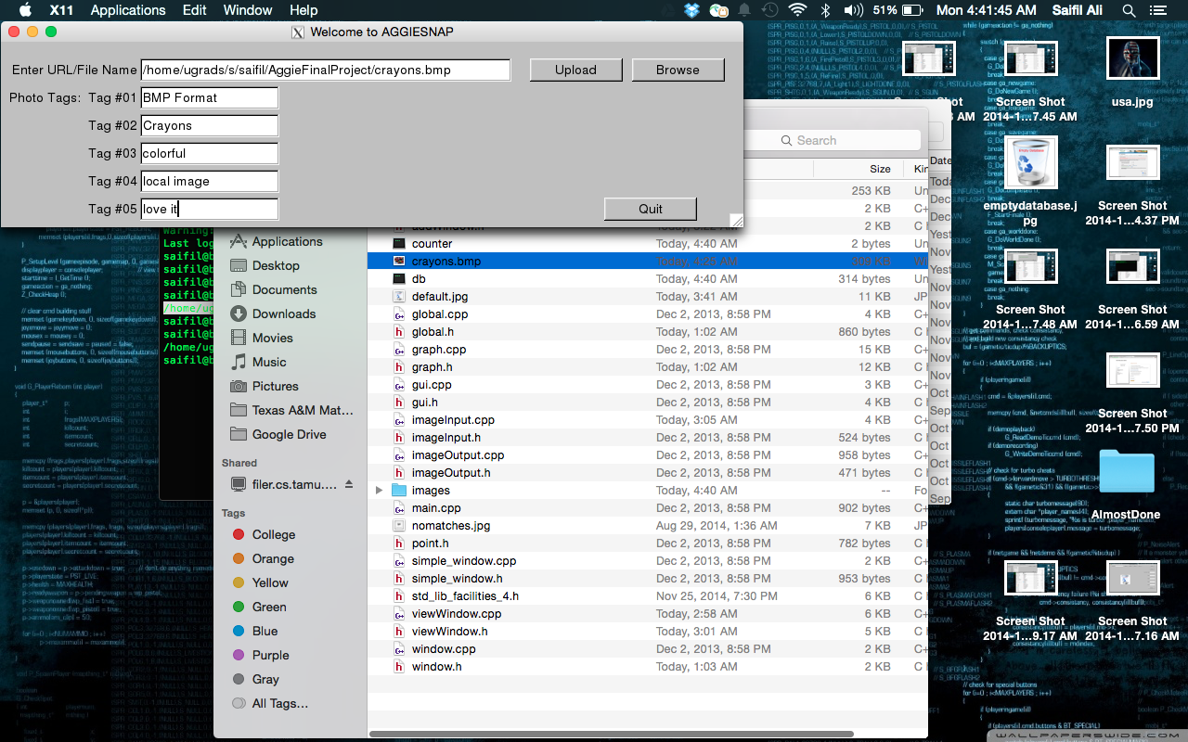

.gif upload with tags

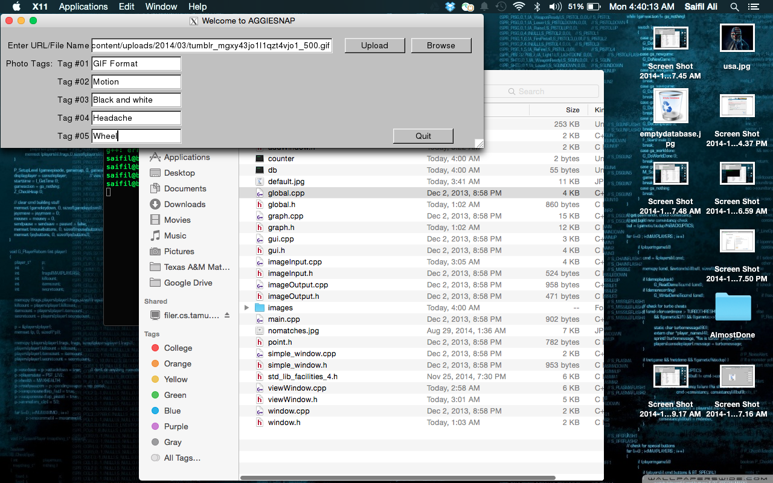

Browse screen with an empty database.png file displayed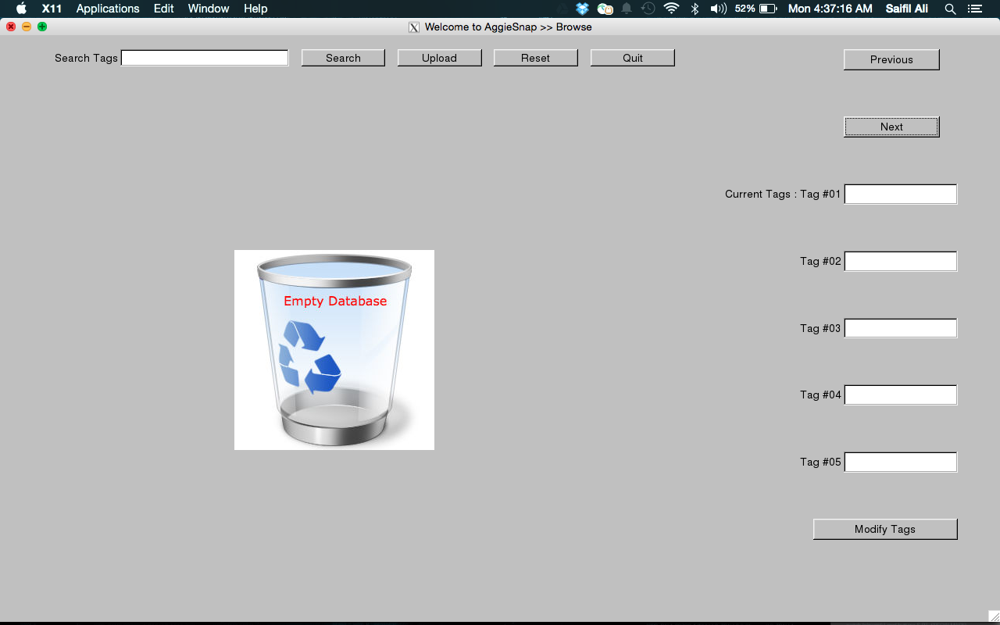.jpg file displayed 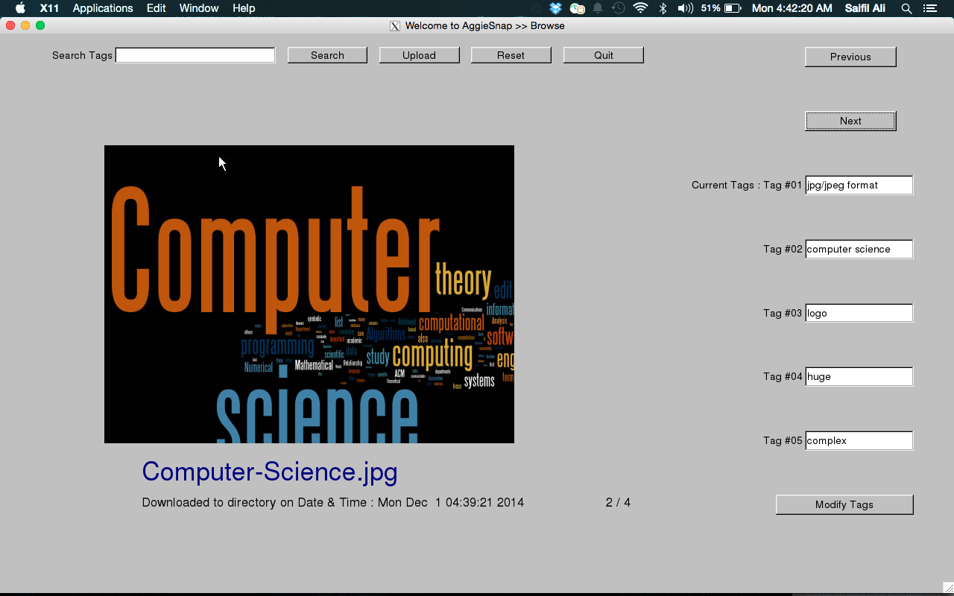

.gif file displayed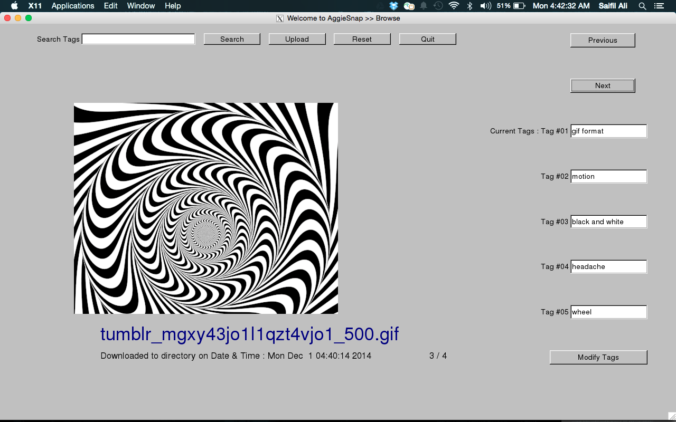.bmp file displayed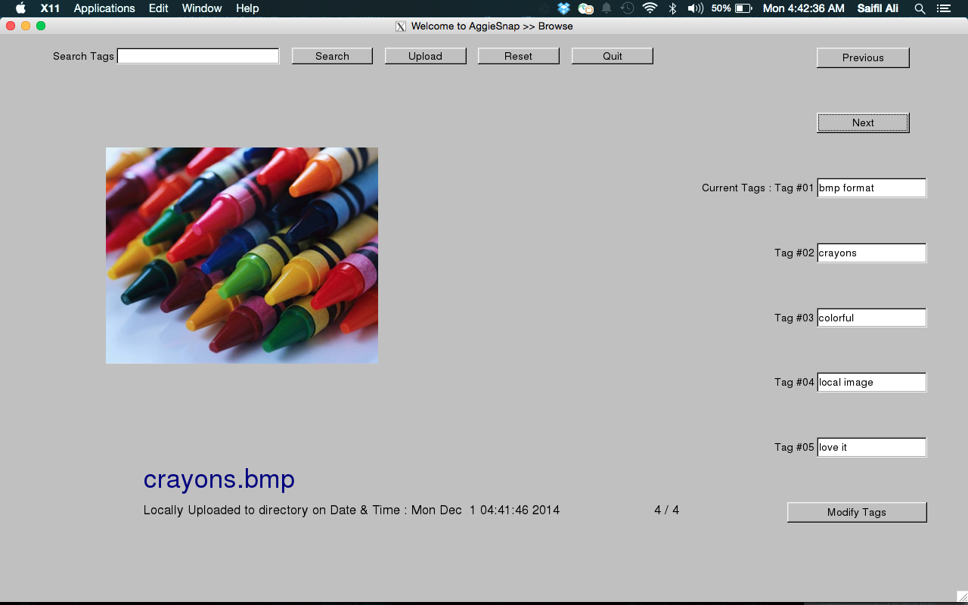Searching an image based on tags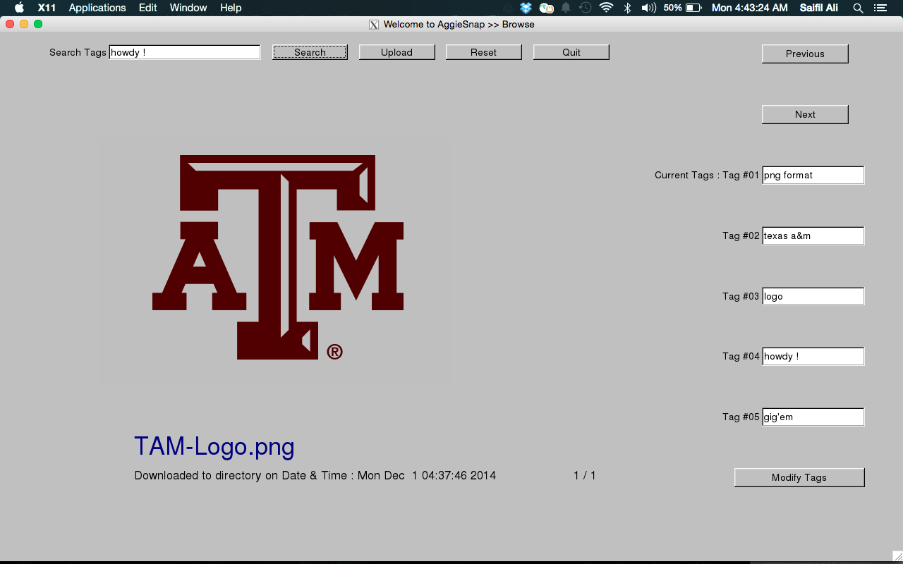Modifying tags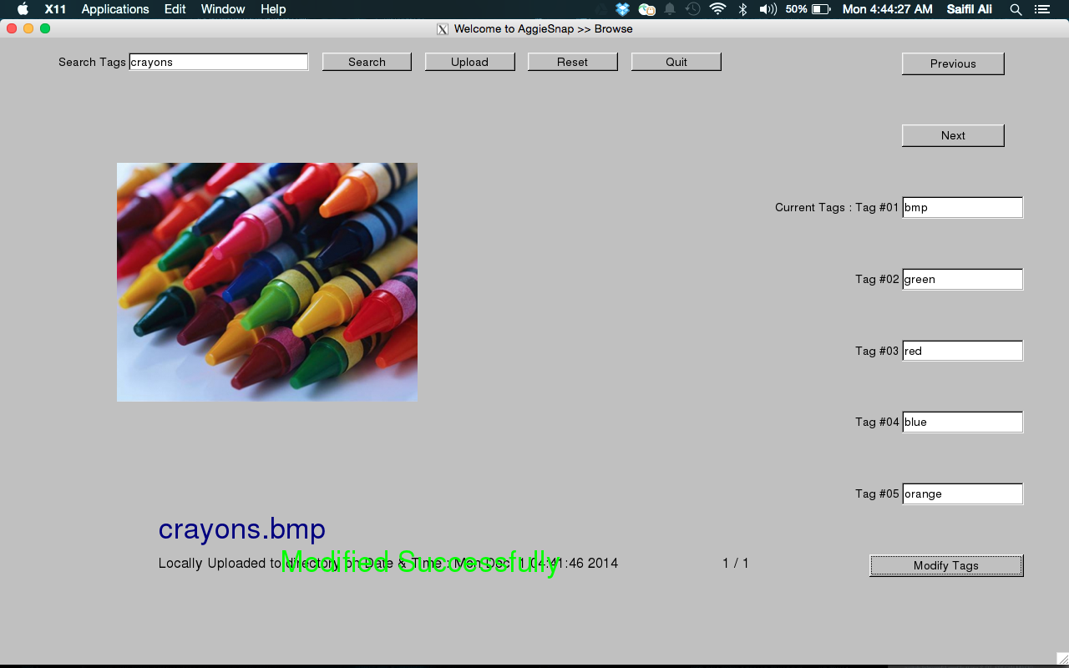

No such tag exists

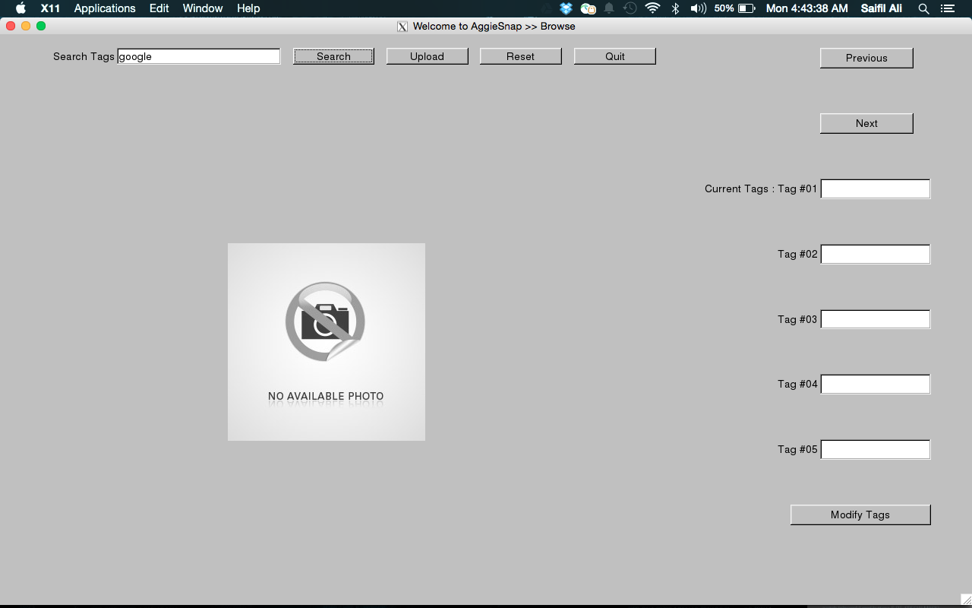

**Instructions for Running the Program**

1. Start by placing the folder “AggieFinalProject” in the location that you most often compile from.
2. Open putty and make sure X11 has forwarding enabled
3. Launch Xming
4. Change your directory to AggieFinalProject
5. Type pwd to get the path for the current folder. Save this to a text file for later.
6. Compile all the files in this folder using the command

**g++ -std=c++14 *.cpp -lfltk -lfltk_images**

1. Run the program using **./a.out**
2. When entering a local picture make sure it is located in the AggieFinalProject folder. Paste the path from step five into the file field and then type the file name immediately after it example: (**/home/ugrads/b/bcschuma/AggieFinalProject/circle.jpg)**
3. Add tags and click upload. Your picture will be added to the browse database
4. To modify your tags do so in te browse window

**Results and Analysis**

After running our program multiple times, under multiple conditions, and even on different platforms it performs up to our teams standards. Under some conditions such as large picture file sizes the program tends to lag to some degree, but that cannot be easily fixed by changing the code. Other than this one bug, no more have been encountered. In regards to the functionality of our program, after showing it to various users, it seems to be very user friendly. Some tweaks could be made to make the file uploading process more seamless, but for an early build this program beyond exceeds ours and our client’s expectations.

**Future Research**

Our project, though it completed many of the required tasks and a few of the extra ones there still are some features our team would like to add in the future. One of these would be the ability to delete unwanted photos from the browse screen after an unwanted upload. One other task we did not get the chance to implement was the ability to resize a picture so it can always be contained in the window. Along these same lines another feature that could be added, is the ability to ascertain the screen size and set the window to those parameters. We hope to include these features in a later build of this project.

**Conclusions**

After completing this project our team feels that we have accomplished to the best of our ability all of the required deliverables, not only those set forward by our client, but those we set for ourselves. We set out to make the best interface we possibly could, and even though there is some room for improvement, with the time we were given we feel that our program is a quality product, and one that we can be proud of. Though this project helped reinforce our skills in C++ programing it has also taught us skills about cooperation in a professional environment. Whether it was dividing the work, the time management, the extra hours put in by group members, or the general teamwork required to complete this task, our team has grown towards becoming better professional individuals. In these past few weeks we have shown that with our skills, though somewhat limited, we can take an idea for a piece of software and see it through from its infancy to its completion. Having learned these lessons it is our hope that we retain what we have learned to make us not only better computer scientists, but better people as well.

**Sources**

"Cplusplus.com - The C++ Resources Network." *Cplusplus.com - The C++ Resources Network*. N.p., n.d. Web. 02 Dec. 2014.

Spitzak, Bill. "FLTK 1.3.3: FLTK Programming Manual." *FLTK 1.3.3: FLTK Programming Manual*. N.p., n.d. Web. 03 Dec. 2014.

"Stack Overflow." *Stack Overflow*. N.p., n.d. Web. 02 Dec. 2014.

Stroustrup, Bjarne *Programming Principles and Practice Using C++.* Crwwfordsville: Pearson, 2014. Print